SQL Hands on

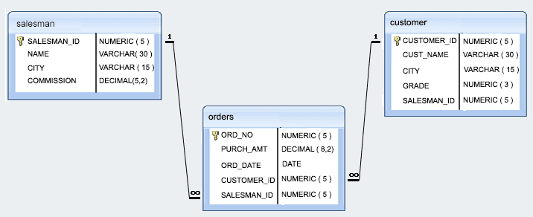

Sample table: customer

customer_id | cust_name | city | grade | salesman_id

-------------+----------------+------------+-------+-------------

3002 | Nick Rimando | New York | 100 | 5001

3007 | Brad Davis | New York | 200 | 5001

3005 | Graham Zusi | California | 200 | 5002

3008 | Julian Green | London | 300 | 5002

3004 | Fabian Johnson | Paris | 300 | 5006

3009 | Geoff Cameron | Berlin | 100 | 5003

3003 | Jozy Altidor | Moscow | 200 | 5007

3001 | Brad Guzan | London | | 5005

Sample table: salesman

salesman_id | name | city | commission

-------------+------------+----------+------------

5001 | James Hoog | New York | 0.15

5002 | Nail Knite | Paris | 0.13

5005 | Pit Alex | London | 0.11

5006 | Mc Lyon | Paris | 0.14

5007 | Paul Adam | Rome | 0.13

5003 | Lauson Hen | San Jose | 0.12

Sample table: orders

ord_no purch_amt ord_date customer_id salesman_id

---------- ---------- ---------- ----------- -----------

70001 150.5 2012-10-05 3005 5002

70009 270.65 2012-09-10 3001 5005

70002 65.26 2012-10-05 3002 5001

70004 110.5 2012-08-17 3009 5003

70007 948.5 2012-09-10 3005 5002

70005 2400.6 2012-07-27 3007 5001

70008 5760 2012-09-10 3002 5001

70010 1983.43 2012-10-10 3004 5006

70003 2480.4 2012-10-10 3009 5003

70012 250.45 2012-06-27 3008 5002

70011 75.29 2012-08-17 3003 5007

70013 3045.6 2012-04-25 3002 5001

1. Write a SQL statement to display all the information of all salesmen.
2. Write a SQL statement to display specific columns like name and commission for all the salesmen
3. Write a query to display the columns in a specific order like order date, salesman id, order number and purchase amount from for all the orders.
4. write a SQL query to find the unique salespeople ID. Return salesman_id.
5. write a SQL query to find the salespeople who lives in the City of 'Paris'. Return salesperson's name, city.
6. write a SQL query to find those customers whose grade is 200. Return customer_id, cust_name, city, grade, salesman_id.
7. write a SQL query to find the orders, which are delivered by a salesperson of ID. 5001. Return ord_no, ord_date, purch_amt
8. Write a SQL query to find the details of the customers who have a gradevalue above 100. Return customer_id, cust_name, city, grade, and salesman_id.
9. write a SQL query to find all the customers in ‘New York’ city who have a grade value above 100. Return customer_id, cust_name, city, grade, and salesman_id.
10. write a SQL query to find the customers who belong to either the city ‘New York’ or have a grade above 100. Return customer_id, cust_name, city, grade, and salesman_id.
11. write a SQL query to find the customers who belong to either the city ‘New York’ or not have a grade above 100. Return customer_id, cust_name, city, grade, and salesman_id.
12. write a SQL query to find those customers who belong to neither the ‘New York’ city nor their grade value exceeds 100. Return customer_id, cust_name, city, grade, and salesman_id.
13. write a SQL query to find details of all order excluding combination of ord_date equal to '2012-09-10' and salesman_id higher than 5005 or purch_amt greater than 1000. Return ord_no, purch_amt, ord_date, customer_id and salesman_id.
14. write a SQL query to find the details of those salespeople whose commissions range from 0.10 to0.12. Return salesman_id, name, city, and commission.
15. write a SQL query to calculate total purchase amount of all orders. Return total purchase amount.
16. write a SQL query to calculate average purchase amount of all orders. Return average purchase amount.
17. write a SQL query to count the number of unique salespeople. Return number of salespeople.
18. write a SQL query to count the number of customers. Return number of customers
19. write a SQL query to find the number of customers who got at least a gradation for his/her activity.
20. write a SQL query to find the maximum purchase amount.
21. write a SQL query to find the minimum purchase amount.
22. write a SQL query to find highest order (purchase) amount by each customer in a particular order date. Filter the result by highest order (purchase) amount above 2000.00. Return customer id, order date and maximum purchase amount
23. write a SQL query to find the maximum order (purchase) amount in the range 2000, 6000 (Begin and end values are included.) by combination of each customer and order date. Return customer id, order date and maximum purchase amount.
24. write a SQL query to find the maximum order (purchase) amount by the combination of each customer and order date. Filter the rows for maximum order (purchase) amount is either 2000, 3000, 5760, 6000. Return customer id, order date and maximum purchase amount.
25. write a SQL query to find the maximum order (purchase) amount by each customer. The customer ID should be in the range 3002 and 3007(Begin and end values are included.). Return customer id and maximum purchase amount.